Peer-to-Peer Overlay and File Sharing

End User Manual

COIT20257: Assessment 1

Lecturer: Wei Li

Tutor: Dat Huynh

Submitted By: Gwendolyn Cabangon
Student Id: 12119839

Contents
Introduction 3
Part A: Framework Components 4
I. Requirements 5
1.1 Java 5
1.2 1.4 Javac 5
1.3 Java Fx 5
1.4 SceneBuilder 6
1.5 Other Tools 7
II. Java Programs, Classes, Files, and GUI Components 8
2.1 Peer-to-Peer Overlay Framework 8
2.2 Peer Folders 8
Part B: Compiling 13
III. Compiling Procedures 14
3.1 Peer 1 Compilation 14
3.2 Peer 2 Compilation 15
3.3 Peer 3 Compilation 16
Part C: Demonstration 17
IV. Launching and Exploring the GUI 18
4.1 Procedures: 18
V. Main Features 22
5.1 Requesting Initial File via IP Multicasting 22
5.2 Receive Search via IP Multicasting 25
5.3 Sending the requested file via TCP stream 26
5.4 Receiving the file via TCP stream 28
5.5 Successful Download 29
5.6 Unsuccessful Download 30
Part D: Key Issues About Upgrading a Client and a Server to a Peer and Overlay Forming 31

Introduction

The program Peer-to-Peer Overlay and File Sharing demonstrates file sharing in an overlay composing of 3 peers. This framework implements UDP datagram and TCP streaming to allow files to be requested by one peer, searched through the other peers in the overlay, and sent back or downloaded when found.
This document serves as the user manual to list down the requirements needed and the procedures for compiling and running the program. Mainly, this document is divided into 4 sections:
Part A: Framework Components – This section presents the requirements needed to develop the program. It discusses the tools, application, and classes used to create the program.
Part B: Compiling – This section demonstrates the proper compiling procedure.
Part C: Demonstration – This section presents the tests cases performed to demonstrate the input, output, and navigation in the GUI.
Part D: Discussion – This section discusses the key issues about upgrading a client and a server to a peer and overlay forming.

Part A: Framework Components

Requirements
This section presents the Java, JDK, JavaFx, and SceneBuilder versions used to develop Peer-to-Peer Overlay and File Sharing.

Java
Java version: 1.8.0_261
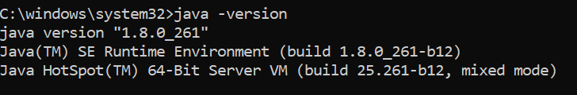

Figure 1.1: Java version

1.4 Javac
Javac version: 1.8.0_261
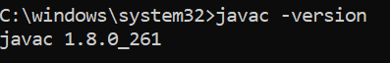

Figure 1.2: Javac version

Java Fx
JavaFx version: 11.0.2
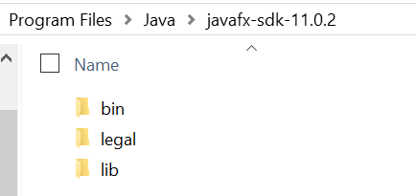

Figure 1.3: Javafx version

SceneBuilder
Scene Builder version: 11
This software was used to layout the GUI elements and linked the elements to java objects and define the ActionEvents.
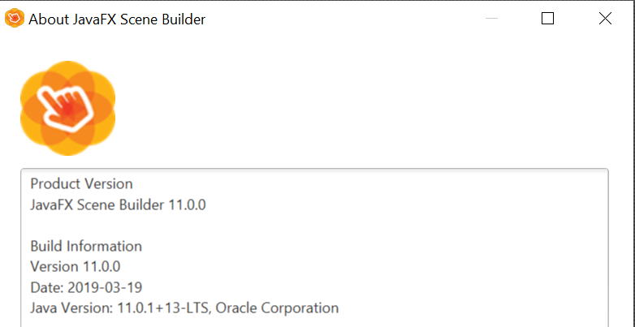

Figure 1.4: SceneBuilder version

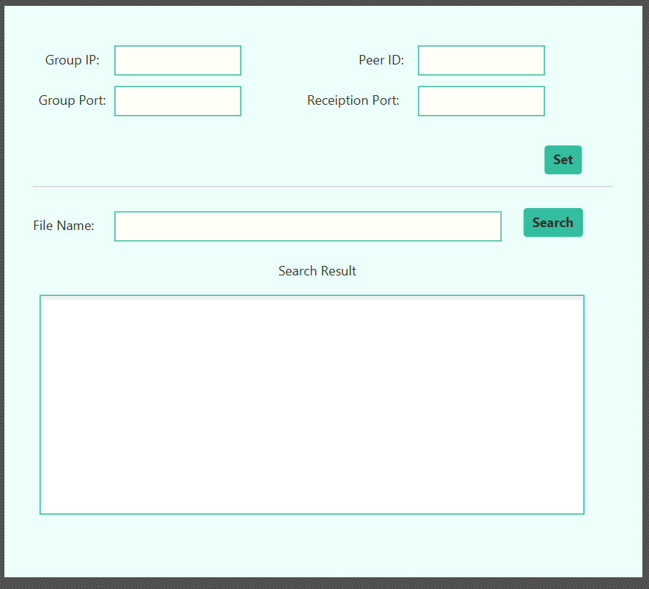

Figure 1.5: GUI layout using SceneBuilder

Other Tools
No IDE was used to develop the framework. The code was written through VSCode as the text editor, and compiled and launched using Command Prompt

Figure 1.5: VSCode and Command Prompt

Java Programs, Classes, Files, and GUI Components
To clearly demonstrate the framework components, the following subsections provide screen captures of the java programs for each peer, the list of java class in each peer, and the files needed for file sharing.

Peer-to-Peer Overlay Framework
The framework has 3 peers in the overlay.
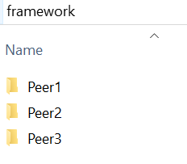

Figure 2.1: Framework peers

Peer Folders
Each peer folder has a “SharingFiles” folder which contains the file/s that are be available for file sharing in the overlay.
To demonstrate the file sharing capability, each peer contains a different file as seen in Figure 2.2.

Figure 2.2: SharingFiles folder

2.3 Java Class, FXML, and Controller Files
Each peer is composed of the following Java Class, FXML, and Controller files:
- ProjectPeer.java – This class contains the main() method to load the FXML file and create the controller object for the GUI.

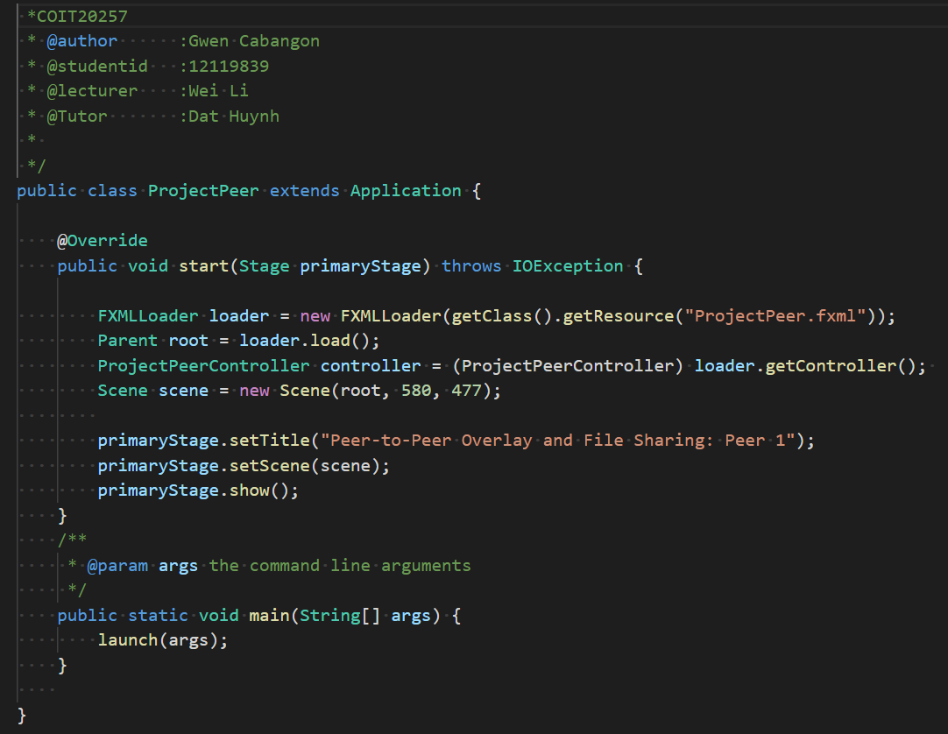

Figure 2.3.1: ProjectPeer.java

- ProjectPeer.fxml – The FXML file contains and defines the JavaFx GUI elements.

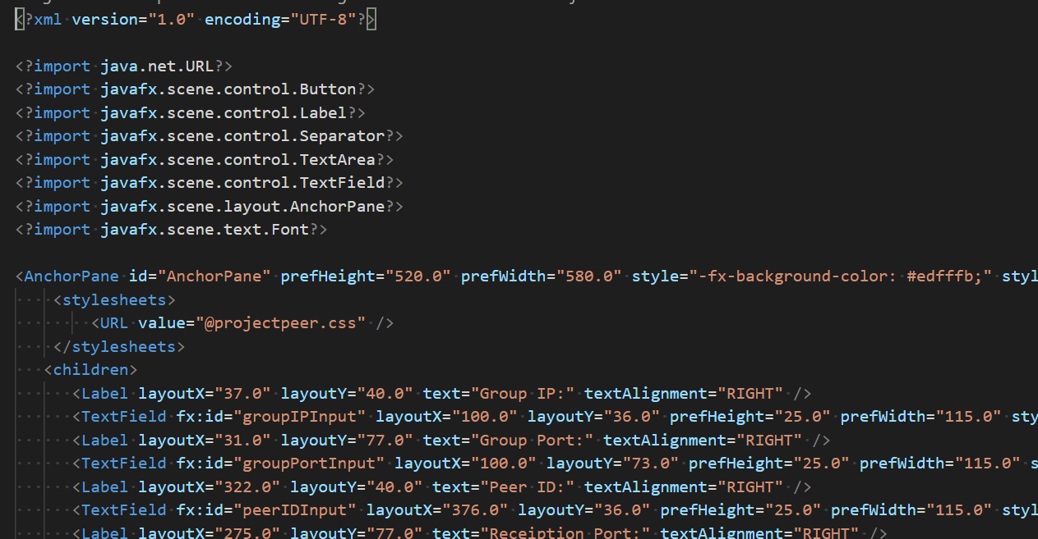

Figure 2.3.2: ProjectPeer.FXML

- ProjectPeerController.java – This is the JavaFx Controller class which holds the ActionEvents and declares the objects/id linked to the GUI elements in the FXML file.

Figure 2.3.3: ProjectPeerController.java

- ReceiveService – This is a multithreaded class which contains the method which holds the multicast receiving end of the peer. The thread is started after clicking the ‘Set’ button in GUI.

Figure 2.3.4: ReceiveService.java

- FileConnection.java – It is a threaded class which contains the TCP receiving end to read and write (download) streamed files.

Figure 2.3.5: FileConnection.java

- FileService.java – This is the entry point for the FileConnection class. This is where the ServerSocket for the TCP receiver is set.

Figure 2.3.6: FileService.java

Part B: Compiling

Compiling Procedures
This section presents the compilation of the java classes for each peer using CMD.
Since the framework is straightforward, the command line javac *.java can be used to compile all java classes in each peer folder.
To compile open cmd and go to the peer’s directory.

Peer 1 Compilation

Figure 3.1.1: Compiling java files in Peer 1

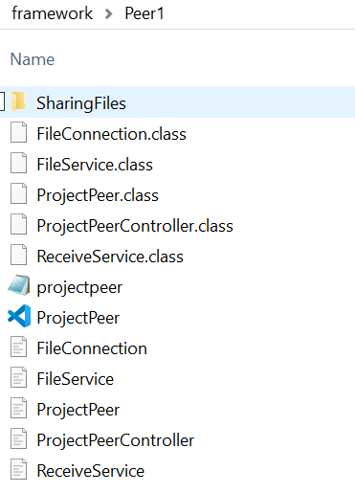

Figure 3.1.2: Peer 1 folder after compilation

3.2 Peer 2 Compilation

Figure 3.2.1: Compiling java files in Peer 2

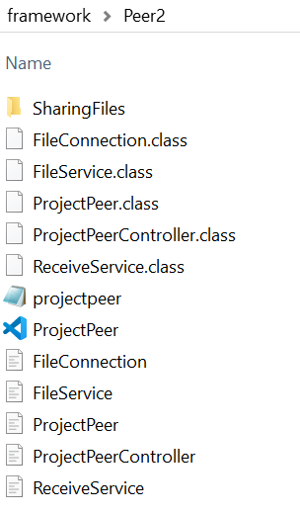

Figure 3.2.2: Peer 2 folder after compilation

3.3 Peer 3 Compilation

Figure 3.3.1: Compiling java files in Peer 3

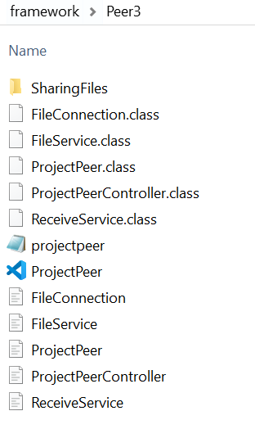

Figure 3.3.2: Peer 3 folder after compilation

Part C: Demonstration

Launching and Exploring the GUI
This section illustrates the procedures for launching each peer program.

4.1 Procedures:
- Open a Command Prompt window for each peer and run the command below:
java ProjectPeer

Figure 4.1: Launching the Peers

- Three JavaFx GUI will appear after running the command. Notice that the fields are pre-populated for the users. This technique may be used to prevent incorrect user input.

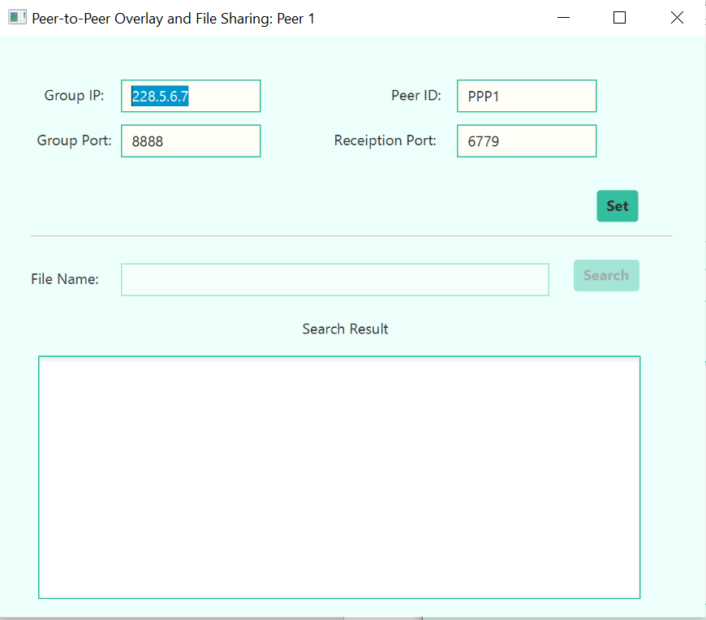

Figure 4.2: Peer 1 interface

The File Name text field and Search button are initially disabled on launch. These will be set enabled after clicking the Set button if the group IP, group port, peer ID, and reception port are valid. Figure 4.5 below presents the setting of text field values and disabling of text field and button when the program is launched. These are defined in the initialize method of the controller class.
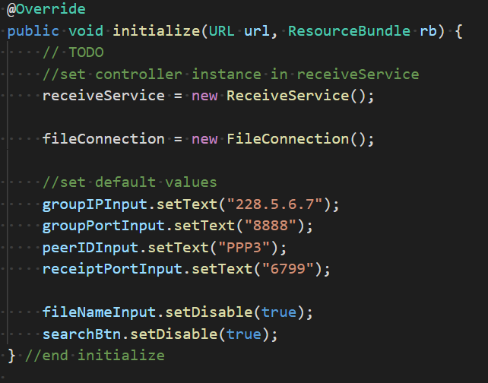

Figure 4.5: Controller initialize()

Figure 4.6 shows the enabled field and button after successfully clicking Set button.

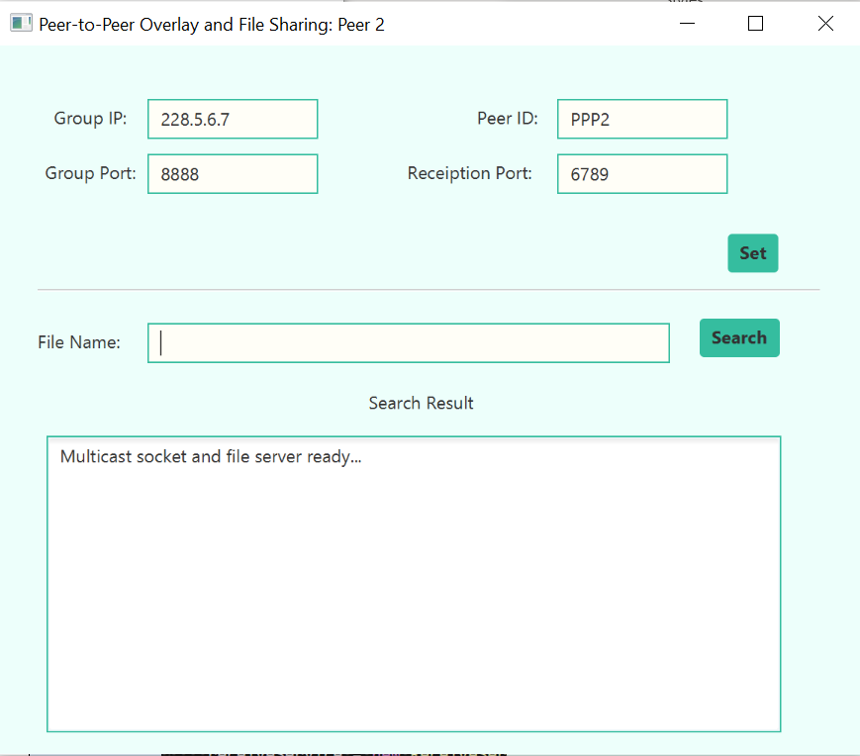

Figure 4.6: File Name text field and Search Button enabled

The Set button action event also holds the starting of IP multicasting receive services and file services.

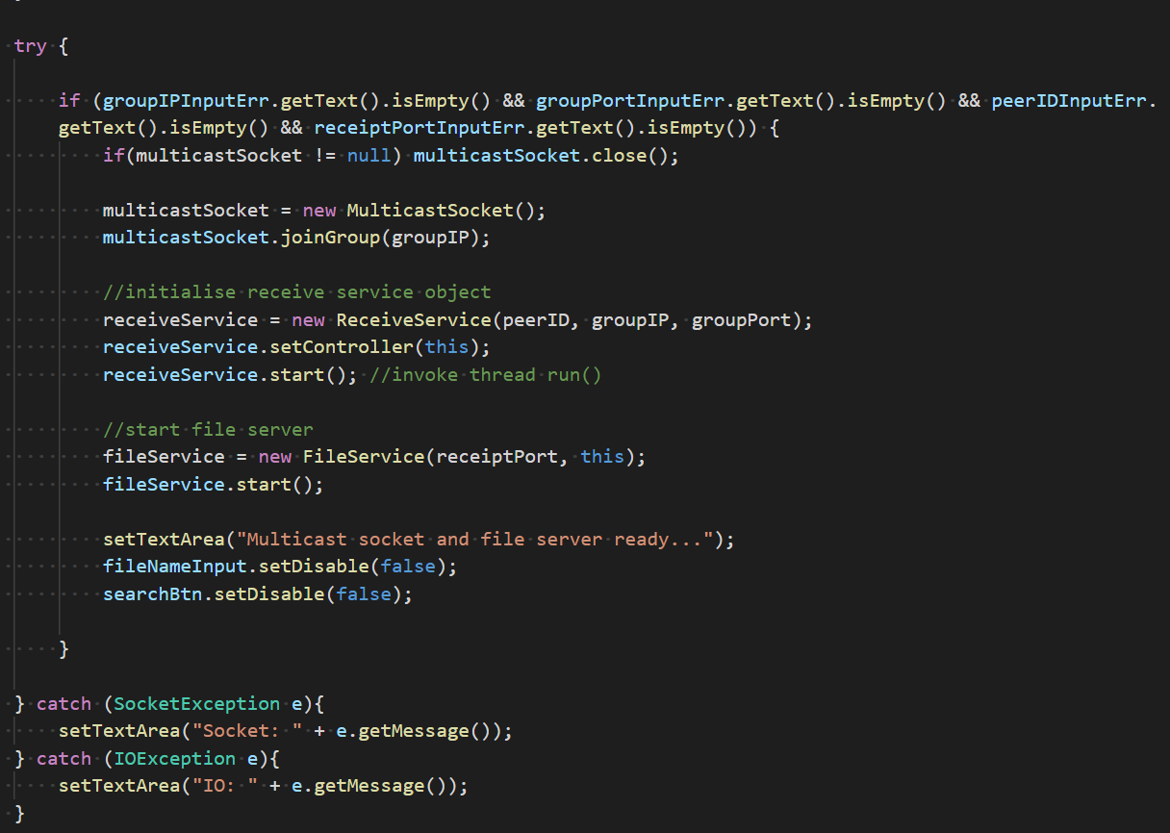

Figure 4.7: start receiveservice and fileservice

- Once the GUI has started, click set button to set the IP, ports, and peer ID.
- Type in the request file in the File Name text field.
- Click search button to proceed to send the requested file.
- The Search Result text area displays appropriate messages for search results.

Main Features
The following subsections demonstrates the actual scenarios of the usage of the programs for file request, transfer, and sharing. Moreover, it presents code snippets to provide further detail on how the desired outcome are being achieved.

Requesting Initial File via IP Multicasting
When the user requests for the initial file inside the SharingFiles folder (see Figure 2.2) a message will be displayed stating that the file exists locally. The search will not proceed to IP multicasting.
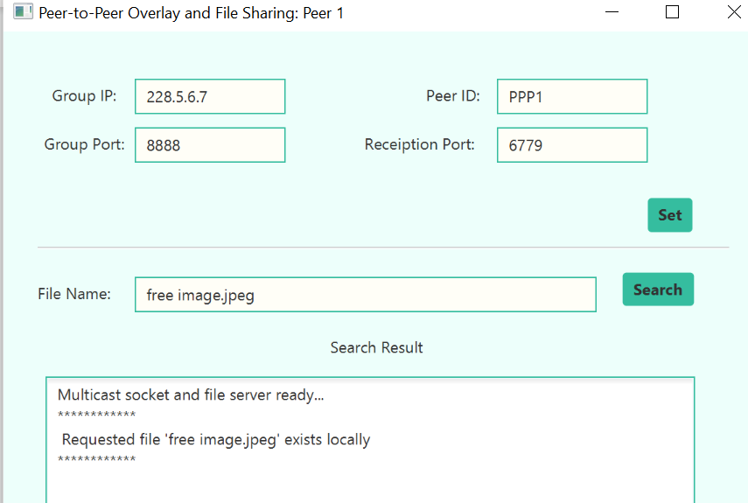

Figure 5.1.1: File exists locally

The action event for the search button detects these to prevent multicasting an existing initial file in the peer SharingFiles folder.
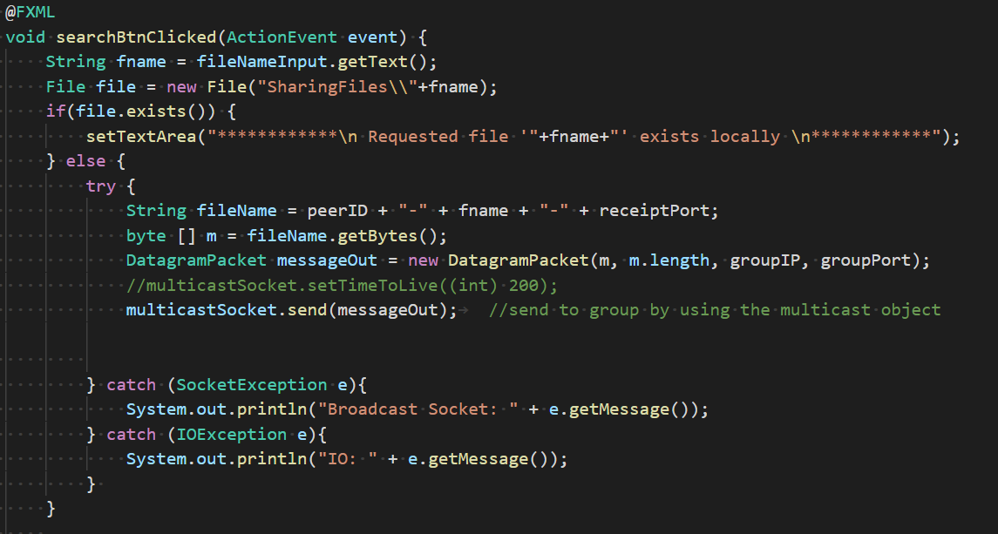

Figure 5.1.2: File exists locally

When a peer searches for a file that exists in another peer, a message in the peer with file will be displayed and a notification will be displayed to the requesting peer that the file being search has been found.
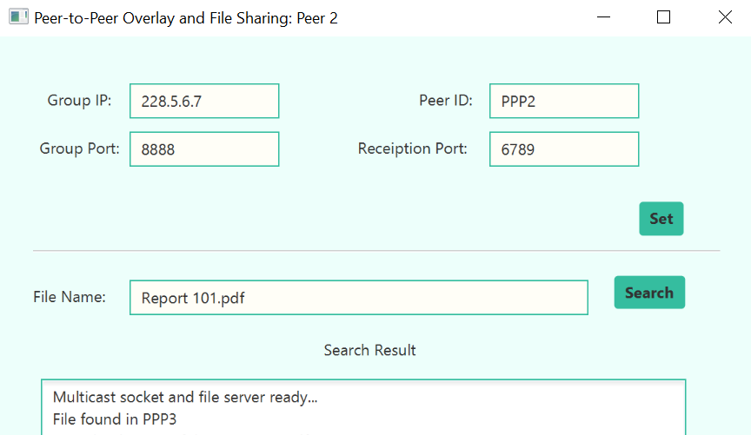

Figure 5.1.3: File found notification to the requesting peer

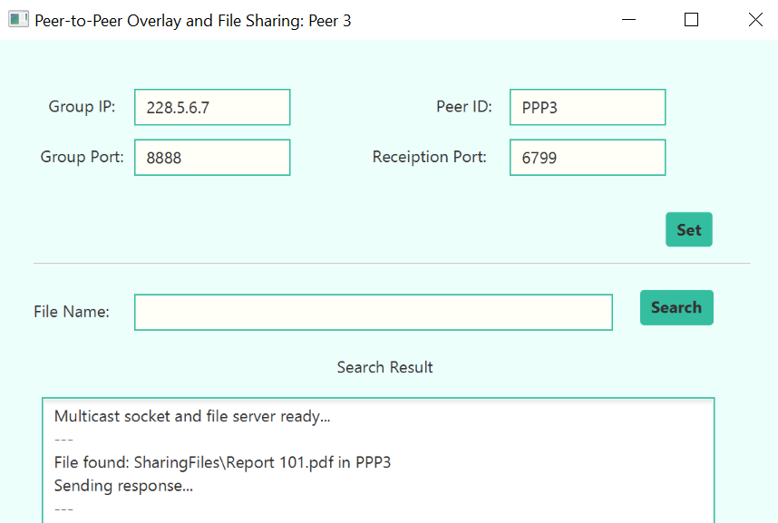

Figure 5.1.4: File found message in the peer with file

Receive Search via IP Multicasting
The requested file is received through the receive services of each peer. To specify that the requesting peer does not send the request to itself, a filter using if-else statement is being used.

Figure 5.2.1: Filtering out requesting peer in multicasted message

5.3 Sending the requested file via TCP stream
If a peer detects that the requested file exists in its SharingFiles folder, it immediately invokes method to send the file over the TCP stream.

Figure 5.3.1: File found message in the peer with file

Figure 5.3.2 shows the detection of the requested file and calling of the sendResponse() method to perform the file sharing.
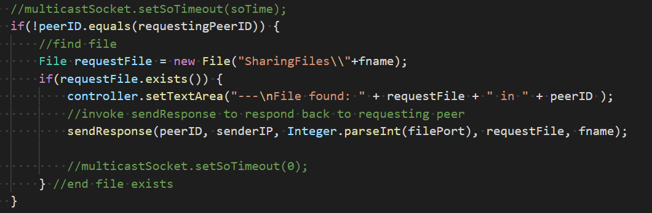

Figure 5.3.2: Search file and send

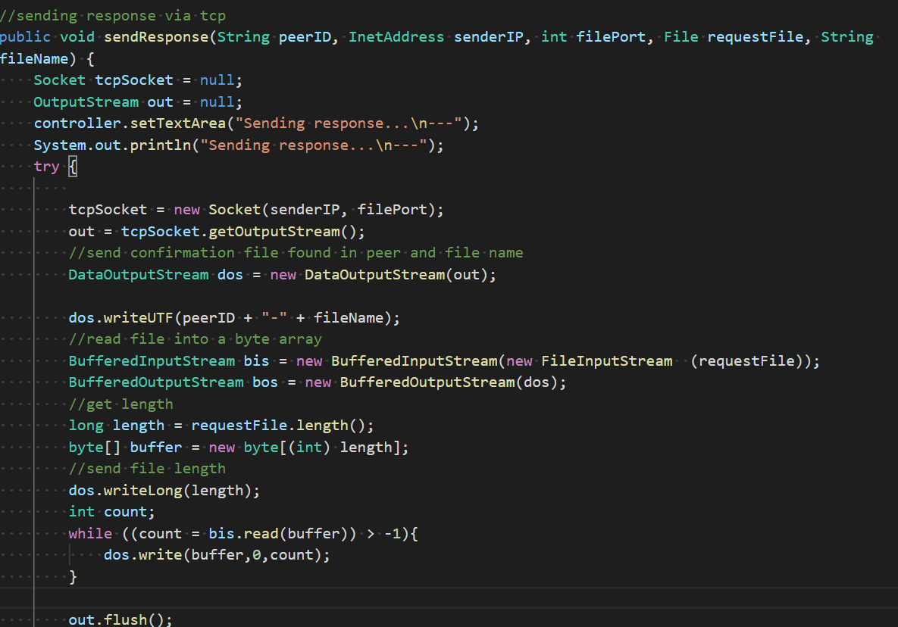

Figure 5.3.4: sendResponse()

Receiving the file via TCP stream
When a file is sent over the TCP stream, the running file connection with handle the receipt of the stream.
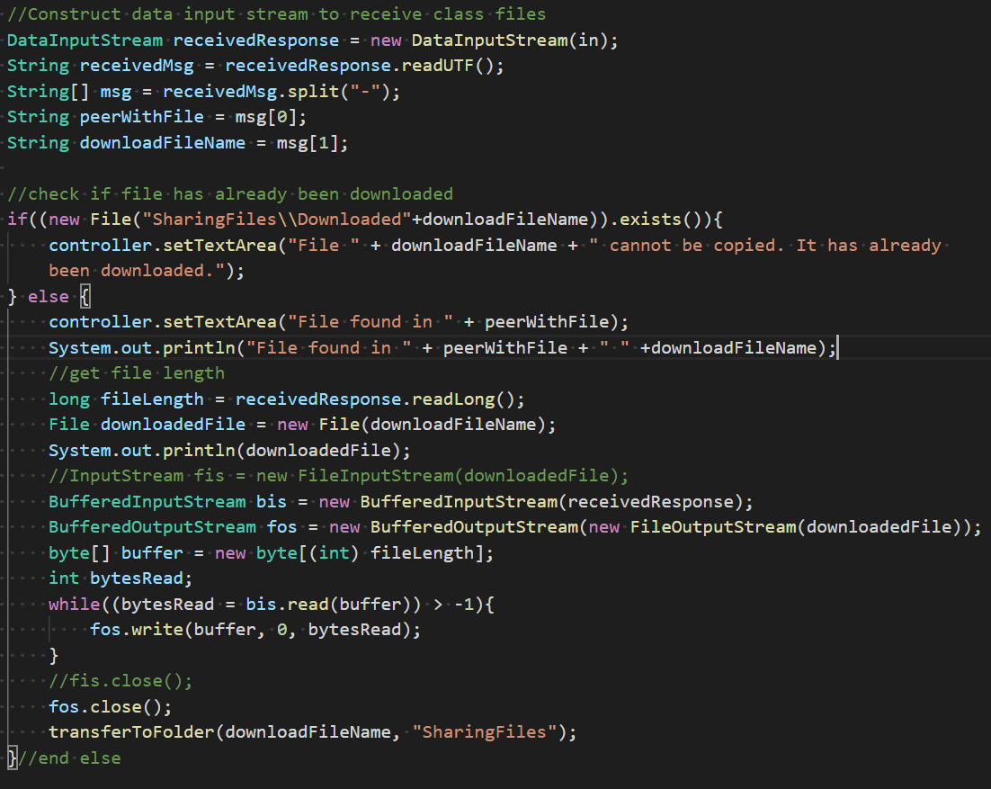

Figure 5.4.1: Receive file

Successful Download
A message will be displayed if the file has been downloaded successfully

Figure 5.5.1: Successful Download

Unsuccessful Download
Appropriate message is being displayed when the requested file has already been downloaded from another peer. If this is detected, the receiving end will no longer proceed to the file reading and writing.

Figure 5.6.1: Unsuccessful Download

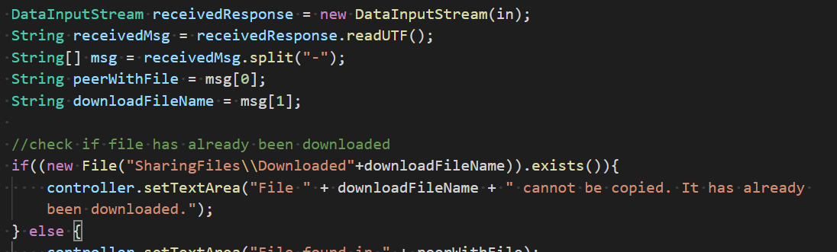

Figure 5.6.2: Detecting previously downloaded file

Part D: Key Issues About Upgrading a Client and a Server to a Peer and Overlay Forming

The main difference of the Peer and Overlay framework from the Client-Server framework is that peer and overlay does not have a centralized in its framework. Each of the peer serves as its own client and server. They are capable of handling request and receive services. Moreover, in peer and overlay forming, the requests and responses are directly being sent and received between peers in the network. Hence, there is shorter turnaround time for each request.

Once of the main concerns when connecting a Client-Server framework into a Peer and Overlay, is the scalability. Peer and Overlay allows direct connection of each network peer. But the performance of this framework deteriorates as the peers increase.

Taking the Peer and Overlay File Sharing program as an example, it is observable that peers can access other peers anytime. The extrapolation from this is that peer-and-overlay has a higher security vulnerability when compared to the client-server network. Lastly, since there is no centralized file management in the framework, it is more challenging to manage files being shared.

